SCHOOL OF COMPUTER SCIENCE AND ARTIFICIAL INTELLIGENCE |  |  |  |  | DEPARTMENT OF COMPUTER SCIENCE ENGINEERING
Program Name: M. Tech/MCA |  |  |  | Assignment Type: Lab |  |  | AcademicYear:2025-2026
Course Coordinator Name |  |  |  | Venkataramana Veeramsetty
Course Code |  |  |  | Course Title |  | AI Assisted Problem Solving Using Python
Year/Sem |  |  | I/I | Regulation |  | R24
Date and Day  of Assignment |  |  | Week1 - Monday | Time(s)
Duration |  |  | 2 Hours | Applicable to  Batches |  | M. Tech/MCA
AssignmentNumber:1.3(Present assignment number)/24(Total number of assignments)
 | Q.No. | Question |  |  |  |  |  | Expected Time  to complete
 | 1 | Lab 1: Environment Setup – GitHub Copilot and VS Code Integration  Lab Objectives:  - To install and configure GitHub Copilot in Visual Studio Code.  - To explore AI-assisted code generation using GitHub Copilot.  - To analyze the accuracy and effectiveness of Copilot's code suggestions.  - To understand prompt-based programming using comments and code context  Lab Outcomes (LOs):  After completing this lab, students will be able to:  - Set up GitHub Copilot in VS Code successfully.  - Use inline comments and context to generate code with Copilot.  - Evaluate AI-generated code for correctness and readability.  - Compare code suggestions based on different prompts and programming styles.  Task Description#1  - Install and configure GitHub Copilot in VS Code. Take screenshots of each step.  Expected Output#1  - Install and configure GitHub Copilot in VS Code. Take screenshots of each step.  Task Description#2  - Use Copilot to generate a is_prime() Python function.  - 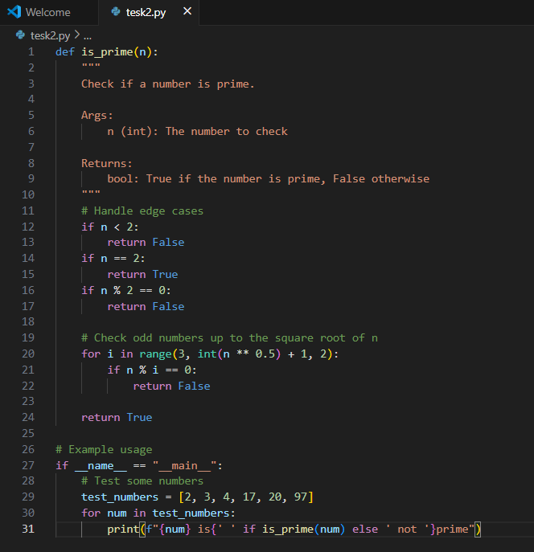  Expected Output#2  - Function to check primality with correct logic.  - 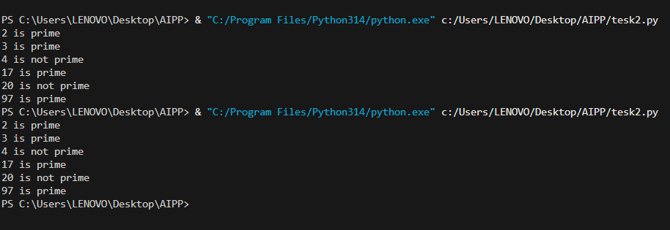  Task Description#3  - Write a comment like # Function to reverse a string and use Copilot to generate the function.  - 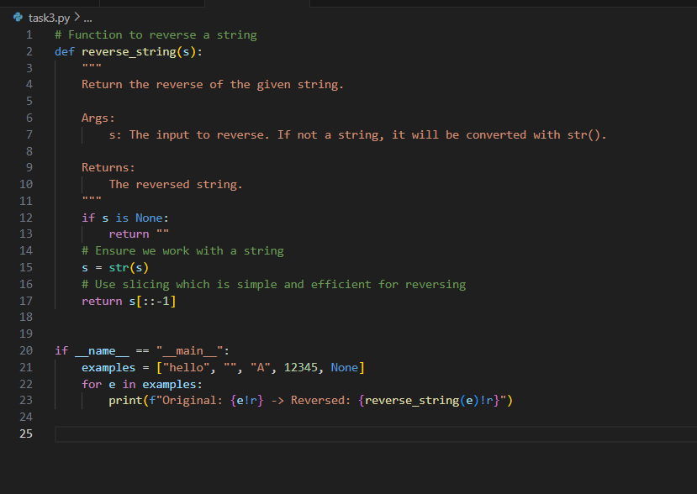  Expected Output#3  - Auto-completed reverse function  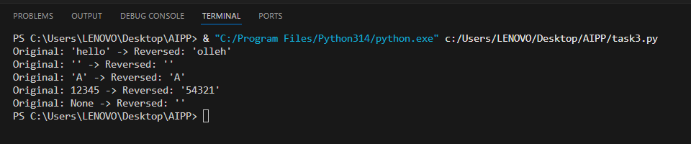  Task Description#4  - Generate both recursive and iterative versions of a factorial function using comments  - 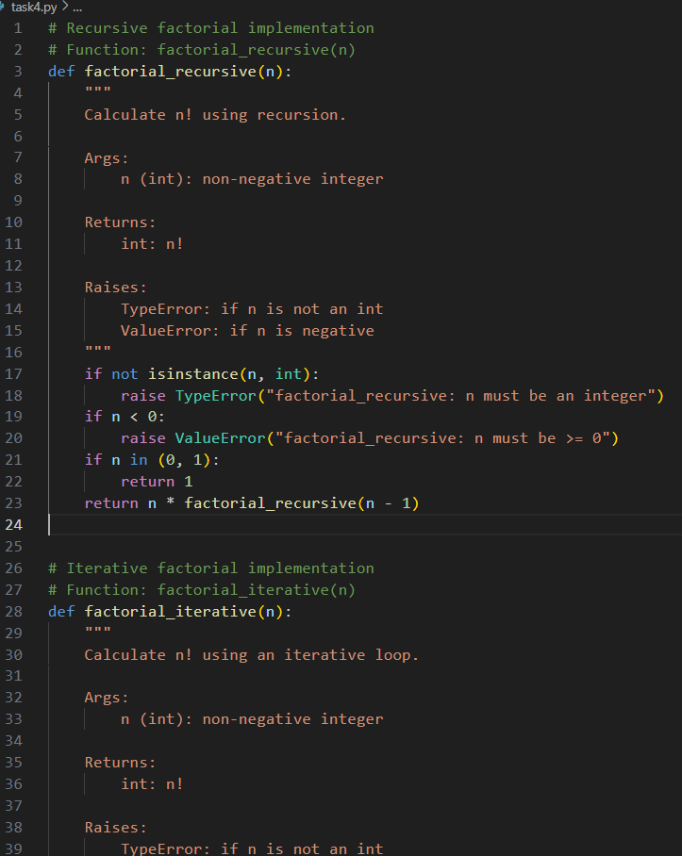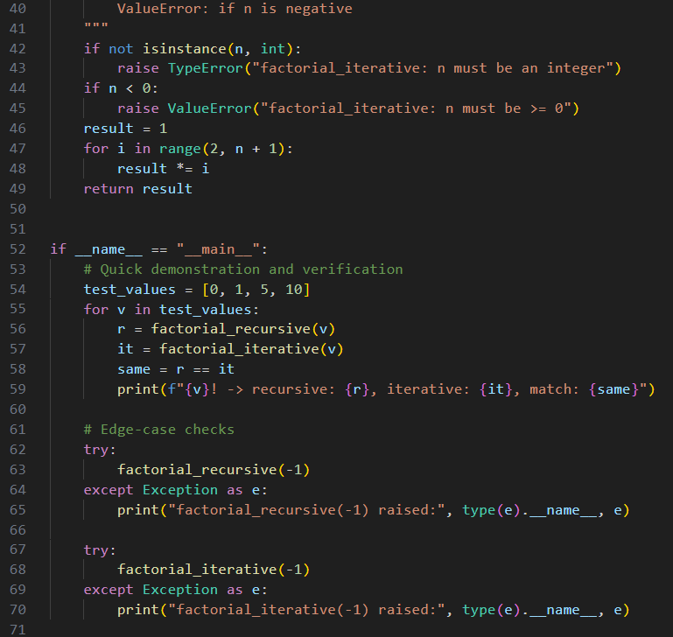..  Expected Output#4  - Two working factorial implementations  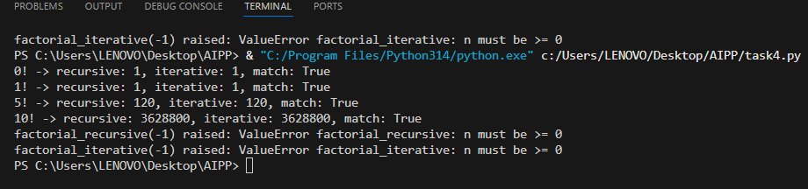  Task Description#5  - Use Copilot to find the largest number in a list. Assess code quality and efficiency.  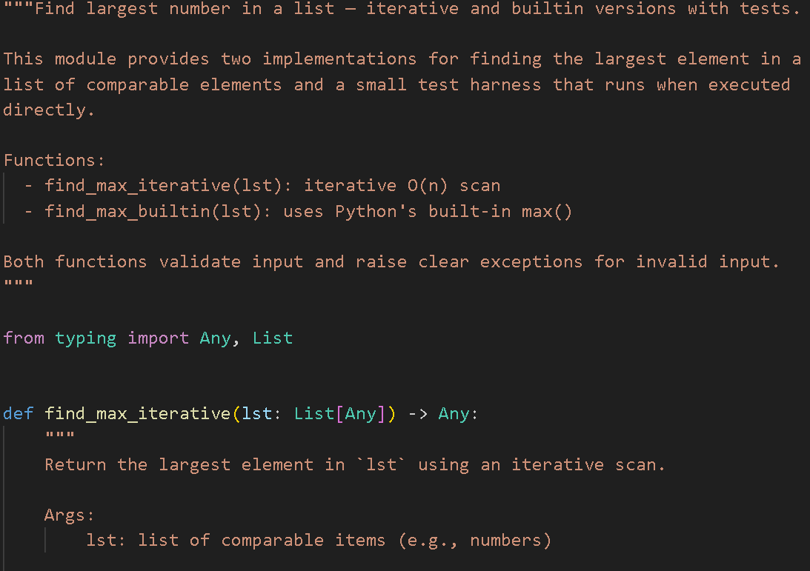  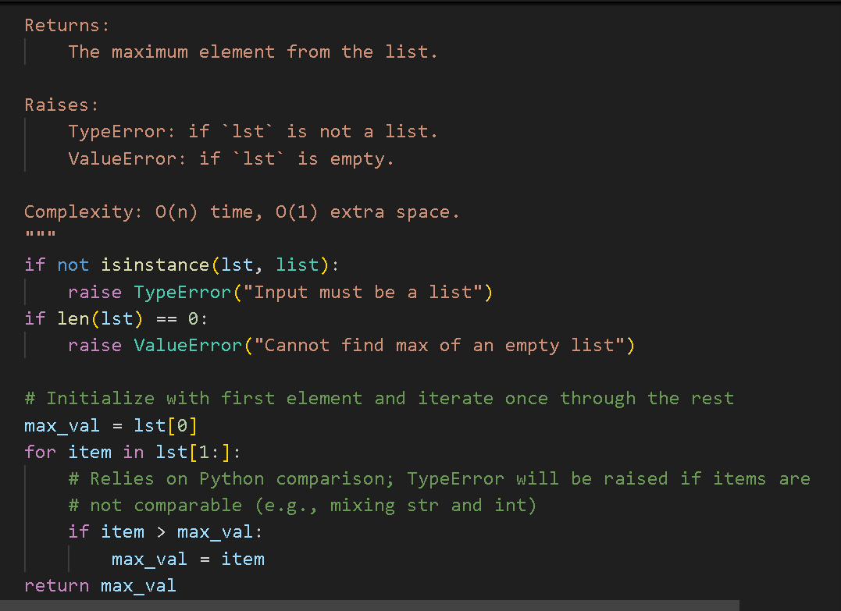  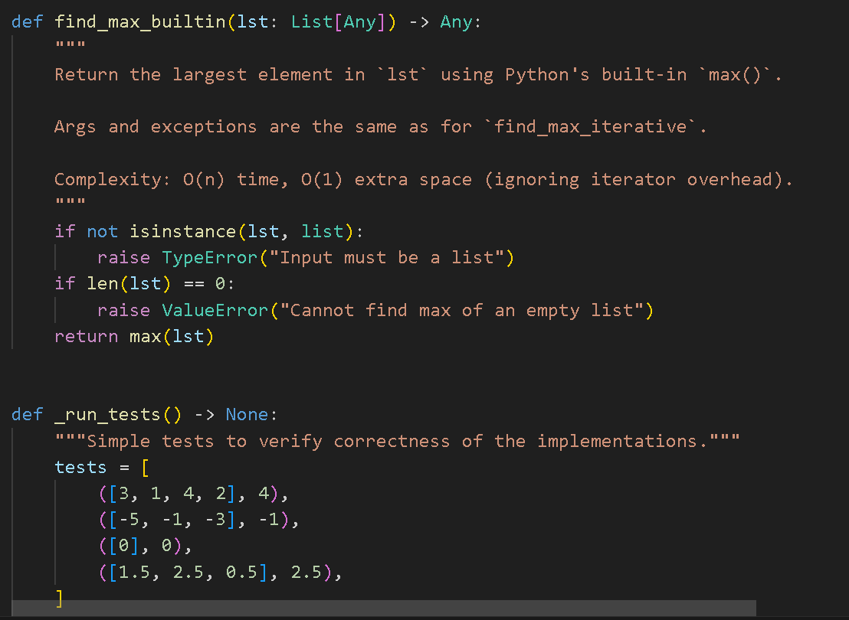  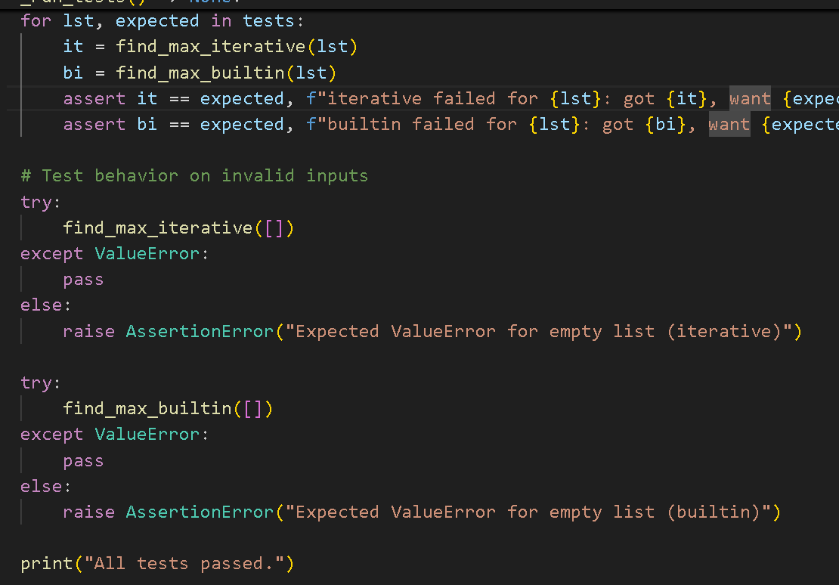  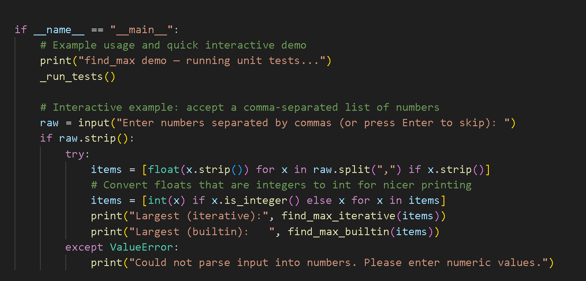  Expected Output#5  - A valid function with your review  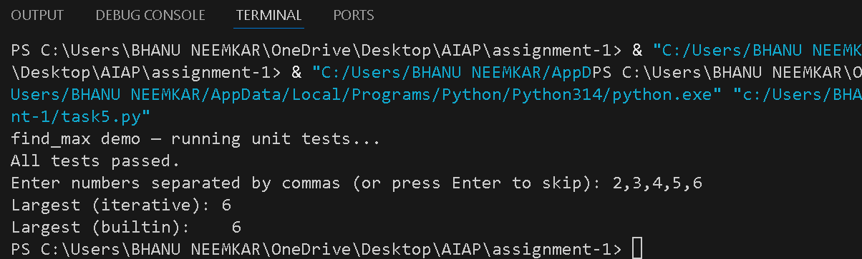  Note: Report should be submitted a word document for all tasks in a single document with prompts, comments & code explanation, and output and if required, screenshots  Evaluation Criteria: |  |  |  |  |  | Week1 - Wednesday
  Criteria | Max Marks
  Successful Setup of Copilot (Task #1) | 2
  is_prime() Python function (Task #2) | 2
  Reverse a string function (Task #3) | 2
  Factorial Function (Task #4) | 2
  Find the largest number (Task #5) | 2
  Total | 10 Marks

